To : The Client
From: 671322649(Karthik Thangasaravanan)
Date: 11/10/2025
Re: Bruce Rauner for Governor Campaign Model

This memo is in response to your request to build a model for converting prospects for donators who want to fund $100 to Bruce Rauner’s Governor Campaign.
Specifically, you requested a model and analysis that would address four questions:
- What percent of total sales are contained in the top 75% of scored prospects?
- What are the variables used in the model?
- Which of those variables are the most impactful and what is their relationship with the probability of making a sale?
- What is an alternative cut-point for the prospect universe?
Results show that the top 75% of prospects contain 87% of the total sales. The variables used in the model are listed in table 1 at the bottom of page 1. The most impactful variables were: The number of trailer policies that the prospects purchased, whether the prospect was a part of the Large Religious families and if the prospect was a part of the Large Family and employed child segment. All of these had a positive association with purchase sales. An alternative cut-point exists at 65% of the prospect universe which contains 81% of the sales. This cut-point was identified using marginal analysis as discussed on page 4.
Top 75% of Prospects. Regression modeling was used to identify the characteristics that were most strongly associated with donations to Bruce Rauner’s campaign. The results of that modeling showed that the top 75% of prospects contained 87% of the total sales. By abstaining from contacting the bottom quarter of the prospect file you can increase your response rate from 5.65% to 6.55%.
Variables in the Model. The variables in the model are shown below in table 1.
Table 1

Variables in the Model and Impact. The variables used in the model for Bruce Runners Campaign model are shown in the table below. You can see the impact of the Contribution of Trailer Policies is 9.80%, meaning for every 1 percent increase in spending on trailer policies the prospect purchased the impact of donations by 9.80%.The slope for Large Religious Families is 7.68%, meaning if the prospect is a part of the Large Religious Families section, then the impact of sales and probability increases by 7.68%. Next, the slope of Large family, employed child is 5.64%, which means if the prospect is a part of the segment of Large family employed child then the probability increases by 5.64
The slopes for all the variables are shown in the table.

Gains Chart. The Gains Chart from the model is shown below. The blue line labeled ‘Baseline’ shows the percentage of campaign donations if prospects were selected on a random basis. That is, we would expect that a random selection of 5% of all prospects to contain 5% of sales; 20% of randomly selected prospects would account for 20% of sales, etc.
The line labeled as ‘Model’ shows analogous results if the model is used to select prospects. You can see that the top 10% of prospects accounts for slightly over 18% of all sales using the model. The spot on the gains chart marked with an arrow shows that the top 75% of prospects accounts for 87% of all donations using the model for Bruce Rauner’s Campaign.

Alternative Cut-Point
The table below shows the increase of donations for every 5% increase in size of the prospect file contact, after sorting from highest to lowest probability of donations based on the model. You can see that after 65% percent of total contacts the difference of donations is approximately below 5% of donations gained. Therefore, if you contacted prospects above 65 percent of total prospects you would then yield 81 percent of total sales.
Table 2
In summary, results show that the top 75% of prospects contain 87% of the total sales. The variables used in the model are listed in table 1 at the bottom of page 1. The most impactful variables were: The number of trailer policies that the prospects purchased, whether the prospect was a part of the Large Religious families and if the prospect was a part of the Large Family and employed child segment. All of these had a positive association with purchase sales. An alternative cut-point exists at 65% of the prospect universe which contains 81% of the sales. This cut-point was identified using marginal analysis as discussed on page 4.

Technical Appendix
This technical appendix provides details as to how the data was prepared for modeling and the construction of the model itself.

Logistic Regression
A logistic regression model was built to identify the characteristics of prospects who are more likely to donate $100 to Bruce Rauners Campaign. The results of that model are shown below. Details regarding the steps preceding the actual model construction follow.
Table 3
Variable Estimate Std..Error z.value Pr...z..
(Intercept) -2.62919808 0.39655693 -6.630065 3.355400e-11
MSKB2 -0.09473044 0.04739645 -1.998682 4.564275e-02
PAANHA 0.66408660 0.12320139 5.390253 7.035873e-08
MGEMOM -0.16653770 0.05443566 -3.059350 2.218182e-03
MOSTYP_39 0.79394310 0.22896195 3.467577 5.251742e-04
MOSTYP_34 0.82968935 0.28293369 2.932452 3.362973e-03
MOSTYP_23 0.63655704 0.22359723 2.846891 4.414841e-03
MOSTYP_2 0.74590046 0.35193690 2.119415 3.405538e-02
MAUT2 0.14826261 0.05610002 2.642826 8.221719e-03
MRELGE -0.09550300 0.04514893 -2.115288 3.440539e-02
MOSHOO_9 0.47671095 0.23835193 2.000030 4.549705e-02

As you can see the p-values are located to the right most column of the model. The P values shown are all less than 5%. Meaning they are statistically significant to the Bruce Rauner Campaign model. All these variables in the regression model are significant even the variables that are close to 5% like MOSHOO_9 and MSKB2. Albeit with less significance compared to the others but there is still an effect. Meaning that there is no bias in any of these variables.

Data Preparation And Variable Selection
The initial file contained 5,422 rows and 28 variables. A number of these variables required adjustment prior to building the model.
Ordinal Variables. The file contained 18 geo-demographic ordinal variables. That is, a particular value for one of these variables represented a range of percentage of people of a certain type in the prospect’s neighborhood. To use these variables in a linear model the original values were re-scaled to the middle of the percentage range. Similarly, the file contained 3 variables regarding the amount spent on certain products. These were similarly transformed as shown in the table below.

L3: Geo Demographic Format L4: Spend Format
Variable Value | Original Value | New Value | Variable Value | Original Value | New Value
0 | 0 | 0% | 0 | $0 | $0
1 | 1-10% | 5.5% | 1 | $1-$49 | $25
2 | 11-23% | 17% | 2 | $50-$99 | $75
3 | 24-36% | 30% | 3 | $100-$199 | $150
4 | 37-49% | 43% | 4 | $200-$499 | $350
5 | 50-62% | 56% | 5 | $500-$999 | $750
6 | 63-75% | 69% | 6 | $1,000-$4,999 | $3,000
7 | 76-88% | 82% | 7 | $5,000-$9,999 | $7,500
8 | 89-99& | 94% | 8 | $10,000-$19,999 | $15,000
9 | 100% | 100% | 9 | $20,000-$? | $30,000

Categorical Variables. Two categorical variables were included in the original file MOSH00 and MOSTYP. They were converted to binary variables 0 and 1 so that they are valid to be used in the regression model. The reason why they were converted is because regression models need to have either binary values or numerical values not categorical values.
Holdout Sample. The split was 70% training records and 30% testing records. The train test split was used to check out how the model handles new records. The training split was used in building the model in r studio meanwhile the testing split was used with the gains chart, the cut point analysis in the business memo. The issue with calculating metrics is on a training model is not ideal due to overfitting, which is why it is best do it on a testing model.

Non-Linear Relationships. Graphs showing the response rate for each of the quantitative variables were reviewed. For those variables that appeared to have a non-linear relationship with response we compared the linear and quadratic AIC values. For example, the graphs below show the pattern of response rate by MGODOV and MBERHO. The pattern is potentially quadratic. Individual logistic regression models for a linear vs. quadratic relationship with response were calculated and the AIC values examined, summarized in the table below.

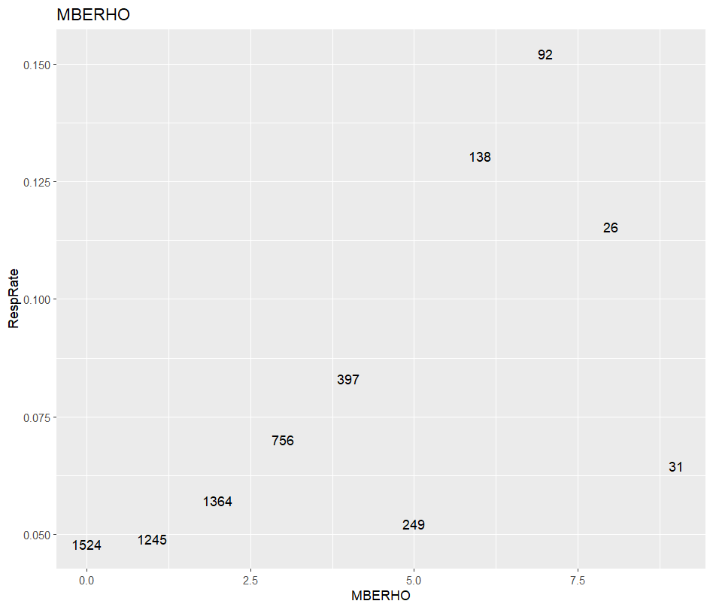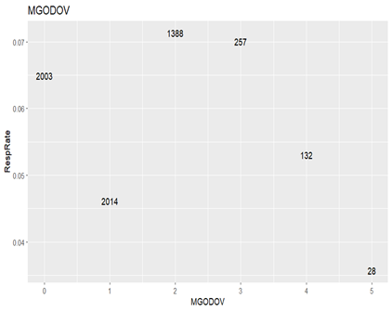
Table 3

Independent Variable | Linear AIC | Quadratic AIC
MGODOV | 2,639 | 2,641
MBERHO | 2,617 | 2,619

The AIC for the linear model was 2,639 vs. 2,641 for quadratic and therefore the linear form was used as a candidate independent variable for logistic regression. As we can see above on table 3 similar results were seen with MBERHO
Logistic Regression Model. After preparing all the variables for potential use in the model, all 26 variables were submitted to a logistic regression model using stepwise variable selection. This resulted in 10 statistically significant variables as shown in table 3.

Linear Regression. After using logistic regression to select the statistically significant variables for the model, the final set of independent variables was used to build a linear regression equation. This was done to see the probability of a response.The coefficients from that model were used to see the general impact or slope of each variable.
RESP = 8.47+ 9.80(Contribution Trailer Policies)+7.68(Large Religions Families)+5.64(Large family employed child)+2.92(Young and Rising)+2.13(Modern Complete Families)+1.01(1 Car)+-0.10(Average Household)+-0.05(Social Class B2)+-0.04(% of Married Families).

Karthik Thangasaravanan.

